news release
CONTACTS:
Kari Mitchell , Marketing Director
1 (713) 465.7575, kmitchell@belltechnologiesllc.com

Dave Bell, Sales Chief Technology Officer
1 (713) 465.7575, dbell@belltechnologiesllc.com

Bell Technologies Introduces High Pressure
Multiphase Mud Flow Solution

HOUSTON, TX (June 1, 2016) – Bell Technologies, LLC introduces the MULTIPHASE TORUSWEDGE™ (MPT) – a high-pressure flow meter for safely measuring multiphase volumetric flow rates for wellbore processes.

The meter is designed to provide high accuracy volumetric flow measurement on drilling rigs and can be used for multiple applications ranging from low to extremely high pressure. The MPT is particularly suited to mud flow where fluid is injected into the well through high-pressure high volume injection pumps. Mud is then returned to the surface through the bell nipple where it flows through the shaker for cleaning prior to being re-circulated back to the wellbore. The product handles demanding applications that require robust performance combined with low maintenance. The MPT will allow operators to confidently monitor mud flow both in and out of the well and ensure long term asset reliability as well as safe operation of the rig.

By monitoring the complete mud flow process, the rig operator will be able to safely control the drilling process and provide a more economically priced wellbore.
The Bell Technologies MPT mud flow meter is a primary flow element with a maximum pressure rating of 20,000 psi. It is designed to handle the higher flow rates and multiphase fluids that are typical in the drilling industry. The MPT is the first ultra-high pressure meter developed by Bell Technologies to address measurement in non-homogeneous situations where other flow meters fail.
“Bell Technologies is currently working with a number of well service companies to develop a variety of mud flow solutions,” said Dave Bell, Owner & Chief Technology Officer of Bell Technologies, LLC. “This new meter is breaking boundaries for flow meters in high pressure applications where virtually every other technology has failed. It delivers value to our customers through more accurate measurement and reduced maintenance over traditional differential pressure and Coriolis technology.”
The primary element used on the MPT is so effective, that Siemens (a global manufacturer of instrumentation) has partnered with Bell Technologies to provide a complete system that monitors mud flow more efficiently and improves safety on drilling rigs. “When coupled with a Siemens DP (differential pressure) transmitter and a PLC (Programmable Logic Controller) with proprietary software, this meter provides safe, reliable and highly repeatable performance with reduced maintenance in the toughest applications,” said Les Bottoms a senior Account Manager with Siemens.
A third party test lab was used in November 2015 to provide test data to support the multiphase claim. The following graph provides data taken when multiphase conditions exist in a Coriolis being utilized for flow rate determination. The multiphase fluid was made up of water, Xanthan gum (carrier fluid), Barite, and air. All data and description of the mudflow system will be provided upon request.
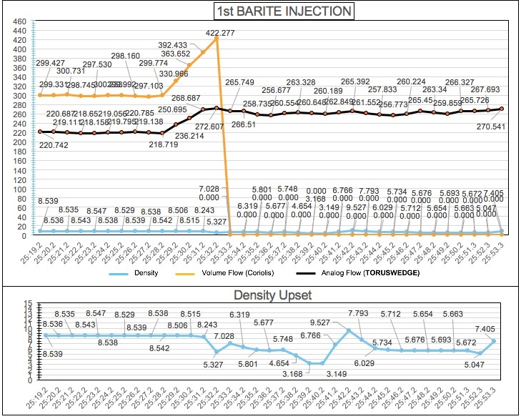
Test Results: The graphs above show that the TORUSWEDGE continues to respond even through multiphase flow when other meters fail. Legend: Orange line is the Coriolis, Black line is the TORUSWEDGE. Blue line is the density of the fluid mixture.
For more information, contact us at 713-465-7575, btllcsales@belltechnologiesllc.com or go to www.belltechnologiesllc.com.

About Bell Technologies LLC

Bell Technologies, LLC, based in Houston, TX, is a global leader in helping businesses create and utilize innovative advancements in differential pressure flow measurement. The company combines technology and innovative engineering together to provide solutions to customers in industrial, commercial and consumer markets. For more information, contact us at 713-465-7575 or go to www.belltechnologiesllc.com.

